***Visoka škola strukovnih studija za informacione I***

***komunikacione tehnologije***

**Dokumentacija**

*(*[*https://mk-international.000webhostapp.com/*](https://mk-international.000webhostapp.com/)*)*

Student: Marko Šćekić

Smer: Internet Tehnologije (Web Programiranje)

Broj indeksa: 331/17

Predmet: Web Programiranje 2

**Sadržaj dokumentacije:**

1. **Uvod** __________________________________________________________________________03

1.1 Korišćeni programski jezici ________________________________________________03

1.2 Opis funkcionalnosti______________________________________________________ 03

2. **Organizacija i izgled** ________________________________________________________ 03

2.1 index.html_______________________________________________________________00

2.2 products.html___________________________________________________________00

2.3 contact.html ____________________________________________________________00

2.4 about.html _____________________________________________________________00

2.5 cart.html ________________________________________________________________00

3. **Kod** ___________________________________________________________00

4. **SEO**____________________________________________________________00

**1. UVOD**

1.1 Korišćeni programski jezici

Za izradu sajta je korišćeno:

* CDN: CloudFlare, JSdeliver
* Framework: Bulma(CSS)
* API: ipify
* Libraries: jQuery, CryptoJS, JS-Cookie, SweeetAlert, FontAwesome

1.2 Opis funkcionalnosti I izgled

Sajt ime sledeće funkcionalnosti:

* ***Responsive***: potpuno je responsive, testirano na monitoru(24”), laptop( 15.6”) I mobilnom uređaju(6”)
* **Dark:** sajt je u tamnijim bojama radi lakseg 'web surfa' noću i u tamnijim prostorijama. Između 20h i 6h slika bulme je crna
* **Dinamički proizvodi**: proizvodi se inicijalno prikazuju u onom redu kako su upisivani u JSON, zatim se mogu filtrirati po veličini I boji. Kada korisnik izabere željeni proizvod, može ga dodati u korpu pritiskom na dugme “Add to cart”
* **Korpa**: proizvodi koje je korisnik ubacio u korpu se prikazuju na stranici cart.htm
* **Forma za kontakt**: nalaze se na strani Contact, odrađena je forma sa validacijom

Javascriptom (jQuery za pozivanje elemenata I sweetalert za obavestenja)

Izgled stranica

2. Organizacija i izgled

2.1 index.html

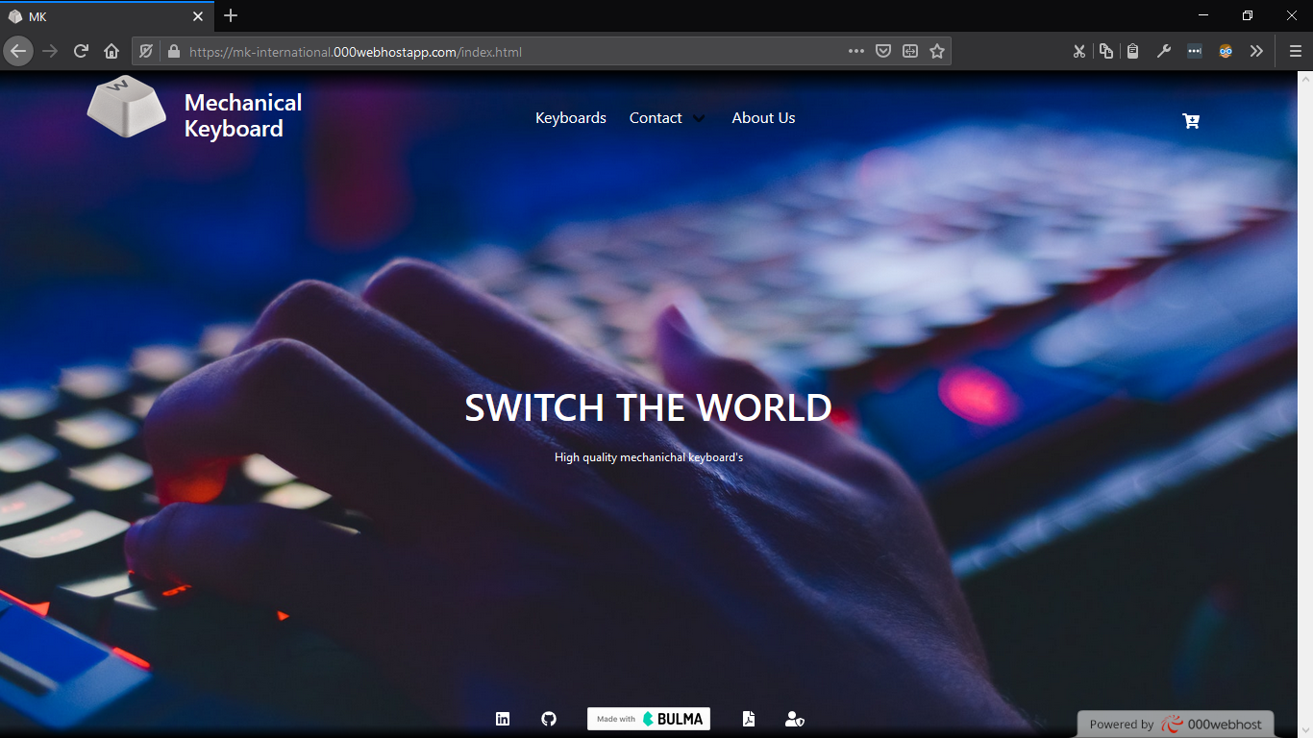

Do indeks stranice se dolazi klikom na ikonicu(beli taster)

2.2 products.html

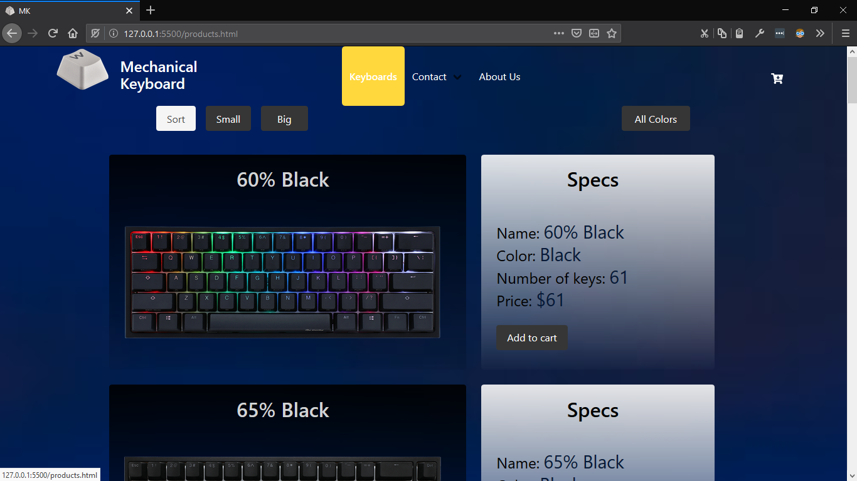Inicijalni izgled stranice *products.html* I prelaskom misa na *Keyboards* sa hover efektom.

Kada se pritisne dugme Add to cart , mala animacija se desi koja traje 0.7 sekundu I imesto teksta je stiklirana ikonica I pored slicice(FontAwesome) korpe pise broj proizvoda u korpi

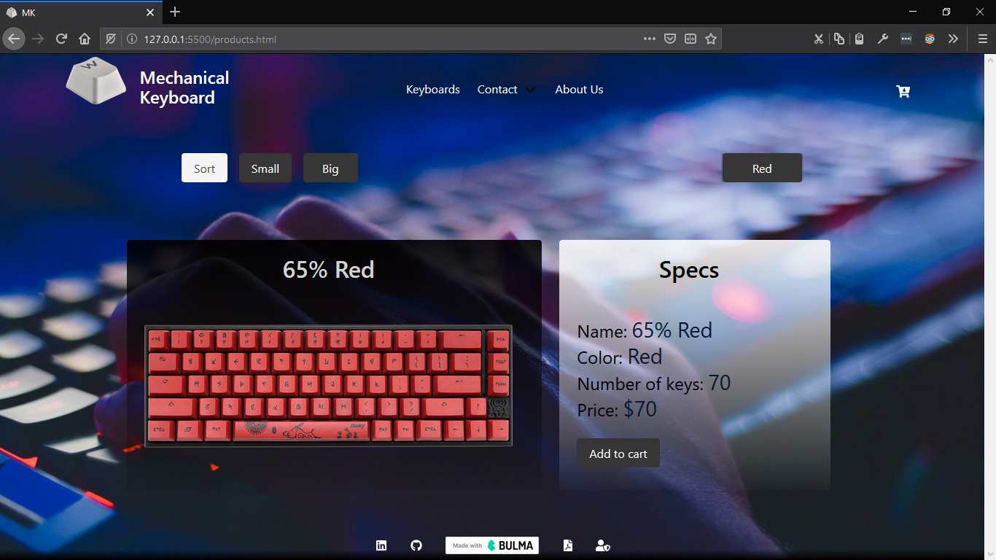Izgled stranice products.html kada se filtriraju tastature u boji crvena

2.3 contact.html

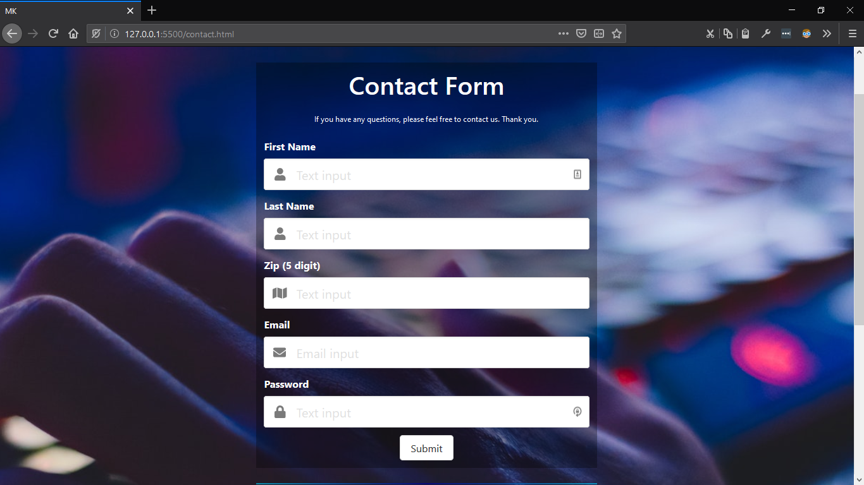

Inicijalni prikaz stranice contact.html

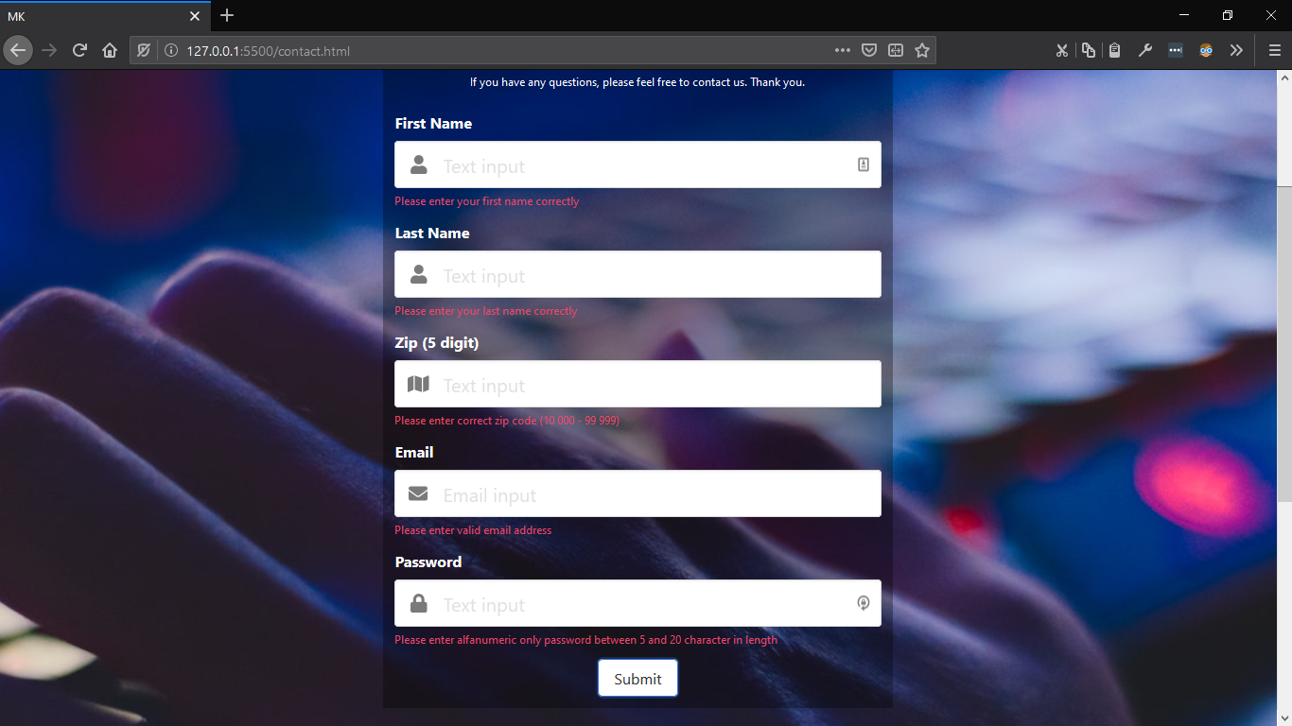 Izgled kada korsnik pogresno unese (sve) podatke

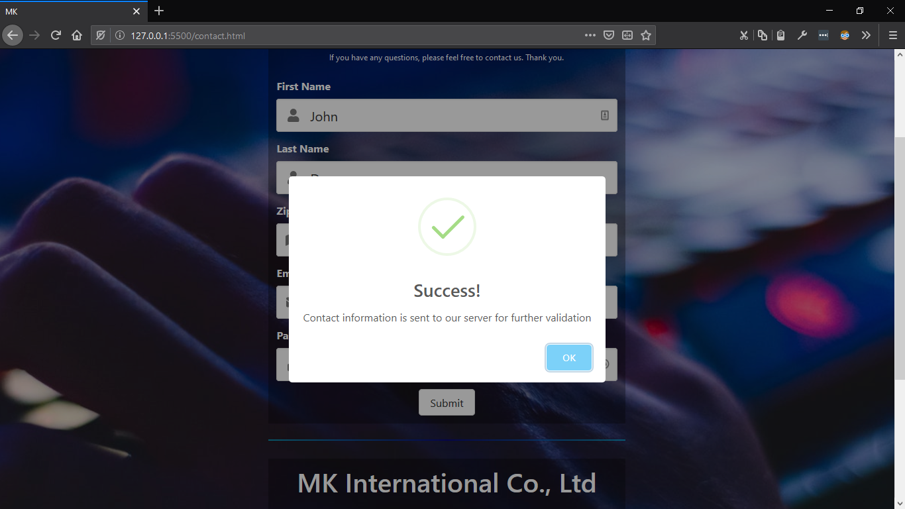 Izgled stranice Contact kada korisnik unese tacne podatke

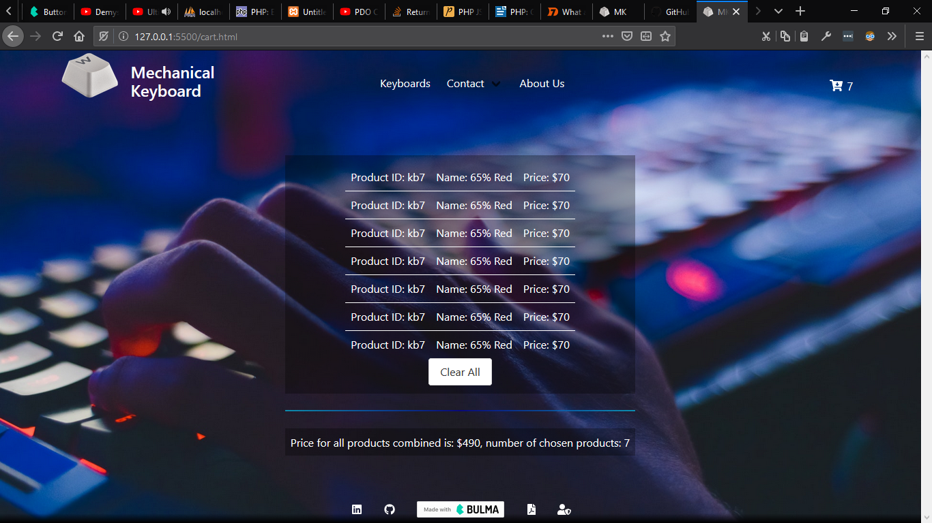

Prikaz stranice cart.html sa 7 proizvoda I ukupnom cenom svih proizvoda

3. Kod

3.1 HTML

3.1.1 index.html

<!DOCTYPE *html*>  
<html *lang*="en">  
  
<head>  
 <meta *charset*="UTF-8">  
 <meta *content*="width=device-width, initial-scale=1" *name*="viewport">  
 <meta *content*="MK International is world renown for its excellent mechanical keyboards" *name*="description" />  
 <title>MK</title>  
 <link *href*="img/pbt-white.png" *rel*="shortcut icon" *type*="image/x-icon" />  
 <link *href*="css/bulma.css" *rel*="stylesheet">  
 *<!-- <link rel="stylesheet" href="css/debug.css"> -->*  
 *<!-- <link rel="stylesheet" href = "https://www.jsdelivr.com/package/npm/bulma"> -->*  
<link *href*="css/helpers.css" *rel*="stylesheet">  
 <link *href*="css/grid.css" *rel*="stylesheet">  
 <link *href*="css/style.css" *rel*="stylesheet">  
 <link *href*="bulma-social.min.css" *type*="text/css">  
 <link *href*="https://cdnjs.cloudflare.com/ajax/libs/font-awesome/4.7.0/css/font-awesome.css" *rel*="stylesheet">  
</head>  
<style>  
 .*hero* {  
 background: url(img/homepageMK.jpg) center/cover;  
  
 }  
  
 *@media* (max-width: 900px) {  
 .*hero* {  
 background: url(img/homepageMK.jpg) center/cover;  
  
 }  
 }  
  
 *@media* (max-width: 420px) {  
 .*hero* {  
 background: url(img/homepageMK-small.jpg) center/cover;  
  
 }  
  
 #mkSwitchH1 {  
 font-size: small;  
 font-weight: 800;  
 }  
  
 #mkSwitch {  
 width: 50px;  
 height: 50px;  
 }  
 }  
</style>  
  
<body>  
  
 *<!--.hero-->*  
<section *class*="hero is-fullheight">  
 <header>  
 <nav *aria-label*="Main navigation" *class*="navbar is-warning" *i d*="navBoja" *role*="navigation">  
 <div *class*="container">  
 <div *class*="navbar-brand is-tablet ">  
 <a *href*="index.html"><img *height*="20" *id*='mkSwitch' *src*="img/pbt-white.png" *width*="90"></a>  
 <p *class*="title is-4 navPBrand" *style*="color:white">Mechanical<br>Keyboard</p>  
 <div *class*="navbar-burger" *data-target*="navbar">  
 <span *style*="color:white"></span>  
 <span *style*="color:white"></span>  
 <span *style*="color:white"></span>  
 </div>  
 </div>  
 <div *class*="navbar-menu navBarAnchor" *id*="navbar" *s tyle*="margin-left: 20%;">  
 <div *class*="navbar-start">  
 <div *class*="navbar-item AboutHover">  
 <a *href*="products.html">  
 <p>Keyboards</p>  
 </a>  
  
 </div>  
 <div *class*="navbar-item has-dropdown is-hoverable AboutHover ">  
 <a *class*="navbar-link aPreventDefault" *h ref*="contact.html">  
 <p>Contact</p>  
 </a>  
 <ul *class*="navbar-dropdown is-boxed">  
 <a *class*="navbar-item burgerColor" *href*="contact.html">Form</a>  
 <a *class*="navbar-item burgerColor" *href*="contact.html#a">Info</a>  
  
 </ul>  
 </div>  
 <div *class*="navbar-item AboutHover">  
 <a *href*="about.html">  
 <p>About Us</p>  
 </a>  
  
 </div>  
  
 </div>  
 <div *class*="navbar-end">  
 <div *class*="buttons has-addons cart">  
 <a *class*="navbar-item has-text-white" *href*="cart.html" *id*="cartAncher">  
 <span *class*="icon is-medium">  
 <i *class*="fa fa-cart-arrow-down"></i>  
 </span></a>  
 </div>  
 </div>  
 </div>  
 </div>  
  
 </nav>  
 </header>  
  
  
 <main *class*="hero-body center" *style*="padding: 2rem;">  
  
  
 <div *id*="grid" *style*="width: 768px;">  
  
 <div *class*="center-column has-text-centered subtitle" *id*="a">  
 <h2 *class*="title is-2 white ">SWITCH THE WORLD</h2><br>  
 <p *class*='content is-small'>High quality mechanichal keyboard's</p>  
  
 </div>  
  
 </div>  
  
 </main>  
  
 *<!-- https://aldi.github.io/bulma-social/ for favicons -->*  
<div *class*="hero-foot" *id*="footerBoja">  
 <nav *class*="tabs">  
 <div *class*="container center-column ">  
 <ul>  
 <li><a *about*="Authors Linkdein profile" *class*="fafaIcons" *href*="">  
 <span *class*="icon is-medium">  
 <i *class*="fab fa-linkedin"></i>  
 <span> </a>  
 </li>  
 <li><a *about*="Authors Github profile" *class*="fafaIcons" *href*="https://github.com/markoscekic98">  
 <span *class*="icon is-medium ">  
 <i *class*="fab fa-github"></i>  
 </span> </a>  
 </li>  
 <li>  
 <a *href*="https://bulma.io" *id*="bulma">  
 </a>  
 </li>  
 <li>  
 <a *about*="All documentation for website" *class*="fafaIcons" *h ref*="documentatio.docx">  
 <span *class*="icon is-medium">  
 <i *class*="fas fa-file-pdf"></i>  
 </span>  
 </a>  
 </li>  
   
 <li>  
 <a *about*="More about author" *class*="fafaIcons" *h ref*="/about.html">  
 <span *class*="icon is-medium">  
 <i *class*="fas fa-user-shield"></i>  
 </span></a>  
 </li>  
   
 </ul>  
 </div>  
 </nav>  
 </div>  
  
 </section>  
  
  
  
  
  
 <script *src*= "https://cdn.jsdelivr.net/combine/npm/jquery@3.4.1/dist/jquery.min.js">

</script>  
 <script *src*=

"https://cdn.jsdelivr.net/npm/js-cookie@beta/dist/js.cookie.min.js"

></script>  
 <script *src*="https://use.fontawesome.com/releases/v5.1.0/js/all.js"></script>  
 <script *src*="https://cdnjs.cloudflare.com/ajax/libs/crypto-js/3.1.2/rollups/aes.js"></script>  
 <script *src*="js/script.js" *type*="text/javascript"></script>  
  
</body>  
  
</html>

3.1.2 products.html

<!DOCTYPE *html*>  
<html *lang*="en">  
  
<head>  
 <meta *charset*="UTF-8">  
 <meta *name*="viewport" *content*="width=device-width, initial-scale=1">  
 <meta *name*="description" *content*="MK International is world renown for its excellent mechanical keyboards" />  
 <title>MK</title>  
 <link *rel*="shortcut icon" *href*="img/pbt-white.png" *id*="ikonica" *type*="image/x-icon" />  
 <link *rel*="stylesheet" *href*="css/bulma.css">  
 *<!-- <link rel="stylesheet" href="css/debug.css"> -->*  
 *<!-- <link rel="stylesheet" href = "https://www.jsdelivr.com/package/npm/bulma"> -->*  
<link *rel*="stylesheet" *href*="/css/helpers.css">  
 <link *rel*="stylesheet" *href*="/css/grid.css">  
 <link *rel*="stylesheet" *href*="/css/style.css">  
 <link *rel*="stylesheet" *href*="/css/bulma-social.min.css">  
 <link *rel*="stylesheet" *href*="https://cdnjs.cloudflare.com/ajax/libs/font-awesome/4.7.0/css/font-awesome.css">  
</head>  
<style>  
 .*hero* {  
 background: url(img/homepageMK.jpg) center/cover;  
  
 }  
  
 *@media* (max-width: 900px) {  
 .*hero* {  
 background: url(img/homepageMK.jpg) center/cover;  
  
 }  
 }  
  
 *@media* (max-width: 420px) {  
 .*hero* {  
 background: url(img/homepageMK-small.jpg) center/cover;  
  
 }  
  
 #mkSwitchH1 {  
 font-size: small;  
 font-weight: 800;  
 }  
  
 #mkSwitch {  
 width: 50px;  
 height: 50px;  
 }  
 }  
</style>  
  
<body>  
  
 *<!--.hero-->*  
<section *class*="hero is-fullheight">  
 <header>  
 <nav *class*="navbar is-warning" *id*="navBoja" *role*="navigation" *aria-label*="Main navigation">  
 <div *class*="container">  
 <div *class*="navbar-brand is-tablet ">  
 <a *href*="index.html"><img *src*="img/pbt-white.png" *id*='mkSwitch' *width*="90" *height*="20"></a>  
 <p *class*="title is-4 navPBrand" *style*="color:white">Mechanical<br>Keyboard</p>  
 <div *class*="navbar-burger" *data-target*="navbar">  
 <span *style*="color:white"></span>  
 <span *style*="color:white"></span>  
 <span *style*="color:white"></span>  
 </div>  
 </div>  
 <div *class*="navbar-menu navBarAnchor" *id*="navbar" *style*="margin-left: 20%;">  
 <div *class*="navbar-start">  
 <div *class*="navbar-item AboutHover">  
 <a *href*="products.html">  
 <p>Keyboards</p>  
 </a>  
  
 </div>  
 <div *class*="navbar-item has-dropdown is-hoverable AboutHover ">  
 <a *href*="contact.html" *class*="navbar-link aPreventDefault">  
 <p>Contact</p>  
 </a>  
 <ul *class*="navbar-dropdown is-boxed">  
 <a *href*="contact.html" *class*="navbar-item burgerColor">Form</a>  
 <a *href*="contact.html#a" *class*="navbar-item burgerColor">Info</a>  
  
 </ul>  
 </div>  
 <div *class*="navbar-item AboutHover">  
 <a *href*="about.html">  
 <p>About Us</p>  
 </a>  
  
 </div>  
  
 </div>  
 <div *class*="navbar-end">  
 <div *class*="buttons has-addons cart">  
 <a *href*="cart.html" *id*="cartAncher" *class*="navbar-item has-text-white">  
 <span *class*="icon is-medium">  
 <i *class*="fa fa-cart-arrow-down"></i>  
 </span></a>  
 </div>  
 </div>  
 </div>  
 </div>  
  
 </nav>  
 </header>  
  
  
 <div *class*="tabs is-centered is-large ">  
 <ul>  
 <li *class*=" is-big" *style*="margin-right: 1rem;"> <span *class*="button is-light">Sort </span></li>  
 <li *class*=" is-big"><span *class*="button is-dark " *id*="smallKeyboardFirst">Small</span></li>  
 <li *class*=" is-big" *style*="margin-left: 1rem;"><span *class*="button is-dark"  
 *id*="bigKeyboardFirst">Big</span></li>  
  
  
 </ul>  
 <ul>  
 <li *class*="is-big">  
 <select *class*="has-dropdown button is-dark" *id*="clickSelectColor">  
 <option *value*="" *class*="selectColor">All Colors</option>  
 <option *value*="Red" *class*="selectColor"> Red</option>  
 <option *value*="Black" *class*="selectColor"> Black</option>  
 <option *value*="Blue" *class*="selectColor"> Blue</option>  
 <option *value*="White" *class*="selectColor"> White</option>  
 <option *value*="Grey" *class*="selectColor">Grey</option>  
 <option *value*="Brown" *class*="selectColor">Brown</option>  
 <option *value*="Pink" *class*="selectColor">Pink</option>  
 </select>  
 </li>  
  
 </ul>  
 </div>  
  
 *<!-- <div id='wrapper'> -->*  
<main *class*="" *id*='keyboardHtml' *style*="padding:0.1rem;">  
  
  
  
 *<!-- <div class="columns is-multiline ">*  
 *<div class="column is-half ">*  
 *<article class="tile is-child notification is-info">*  
 *<p class="title">Middle tile</p>*  
 *<p class="subtitle">With an image</p>*  
  
 *</article>*  
 *</div>*  
 *</div>*  
  
 *<div class="columns is-multiline is-centered">*  
 *<div class="column is-half ">*  
 *<article class="tile is-child notification is-info">*  
 *<figure class="image ">*  
 *<img src="img/keyboards/60.png">*  
 *</figure>*  
  
  
 *</article>*  
 *</div>*  
 *<div class="column is-one-quarter ">*  
 *<article class="tile is-child notification is-info">*  
 *<p class="title">Middle tile</p>*  
 *<p class="subtitle">With an image</p>*  
  
 *</article>*  
 *</div>*  
 *<div class="column is-one-quarter ">*  
 *<article class="tile is-child notification is-danger">*  
 *<p class="title">Middle tile</p>*  
 *<p class="subtitle">With an image</p>*  
  
 *</article>*  
 *</div>*  
 *</div>*  
*-->*  
</main>  
  
  
 <div *class*="hero-foot" *id*="footerBoja">  
 <nav *class*="tabs">  
 <div *class*="container center-column ">  
 <ul>  
 <li><a *href*="linkedin.com/in/marko-scekic-567761174" *class*="fafaIcons" *about*="Authors Linkdein profile">  
 <span *class*="icon is-medium">  
 <i *class*="fab fa-linkedin"></i>  
 <span> </a>  
 </li>  
 <li><a *href*="https://github.com/markoscekic98" *class*="fafaIcons" *about*="Authors Github profile">  
 <span *class*="icon is-medium ">  
 <i *class*="fab fa-github"></i>  
 </span> </a>  
 </li>  
 <li>  
 <a *id*="bulma" *href*="https://bulma.io">  
 </a>  
 </li>  
 <li>  
 <a *href*="documentatio.docx" *class*="fafaIcons" *about*="All documentation for website">  
 <span *class*="icon is-medium">  
 <i *class*="fas fa-file-pdf"></i>  
 </span>  
 </a>  
 </li>  
   
 <li>  
 <a *href*="/about.html" *class*="fafaIcons" *about*="More about author">  
 <span *class*="icon is-medium">  
 <i *class*="fas fa-user-shield"></i>  
 </span></a>  
 </li>  
   
 </ul>  
 </div>  
 </nav>  
 </div>  
  
 </section>  
  
  
  
  
  
 <script *src*="https://cdn.jsdelivr.net/combine/npm/jquery@3.4.1/dist/jquery.min.js"></script>  
 <script *src*="https://cdn.jsdelivr.net/npm/js-cookie@beta/dist/js.cookie.min.js"></script>  
 <script *src*="https://use.fontawesome.com/releases/v5.1.0/js/all.js"></script>  
 <script *src*="https://cdnjs.cloudflare.com/ajax/libs/crypto-js/3.1.2/rollups/aes.js"></script>  
 <script *type*="text/javascript" *src*="js/script.js"></script>  
  
</body>  
  
</html>

3.1.3 contact.html

<!DOCTYPE *html*>  
<html *lang*="en">  
  
  
<head>  
 <meta *charset*="UTF-8">  
 <meta *name*="viewport" *content*="width=device-width, initial-scale=1">  
 <meta *name*="description" *content*="MK International is world renown for its excellent mechanical keyboards"/>  
 <title>MK</title>  
 <link *rel*="shortcut icon" *href*="img/pbt-white.png" *id*="ikonica" *type*="image/x-icon"/>  
 <link *rel*="stylesheet" *href*="css/bulma.css">  
 *<!-- <link rel="stylesheet" href="css/debug.css"> -->*  
 *<!-- <link rel="stylesheet" href = "https://www.jsdelivr.com/package/npm/bulma"> -->*  
<link *rel*="stylesheet" *href*="/css/helpers.css">  
 <link *rel*="stylesheet" *href*="/css/grid.css">  
 <link *rel*="stylesheet" *href*="/css/style.css">  
 <link *rel*="stylesheet" *href*="/css/bulma-social.min.css">  
 <link *rel*="stylesheet" *href*="https://cdnjs.cloudflare.com/ajax/libs/font-awesome/4.7.0/css/font-awesome.css">  
</head>  
<style>  
 .*hero* {  
 background: url(img/homepageMK.jpg) center/cover;  
  
 }  
  
 *@media* (max-width: 900px) {  
 .*hero* {  
 background: url(img/homepageMK.jpg) center/cover;  
  
 }  
 }  
  
 *@media* (max-width: 420px) {  
 .*hero* {  
 background: url(img/homepageMK-small.jpg) center/cover;  
  
 }  
 }  
</style>  
  
<body>  
  
*<!--.hero-->*  
<section *class*="hero is-fullheight">  
 <header>  
 <nav *class*="navbar is-warning" *id*="navBoja" *role*="navigation" *aria-label*="Main navigation">  
 <div *class*="container">  
 <div *class*="navbar-brand is-tablet ">  
 <a *href*="index.html"><img *src*="img/pbt-white.png" *id*='mkSwitch' *width*="90" *height*="20"></a>  
 <p *class*="title is-4 navPBrand" *style*="color:white">Mechanical<br>Keyboard</p>  
 <div *class*="navbar-burger" *data-target*="navbar">  
 <span *style*="color:white"></span>  
 <span *style*="color:white"></span>  
 <span *style*="color:white"></span>  
 </div>  
 </div>  
 <div *class*="navbar-menu navBarAnchor" *id*="navbar" *style*="margin-left: 20%;">  
 <div *class*="navbar-start">  
 <div *class*="navbar-item AboutHover">  
 <a *href*="products.html">  
 <p>Keyboards</p>  
 </a>  
  
 </div>  
 <div *class*="navbar-item has-dropdown is-hoverable AboutHover ">  
 <a *href*="contact.html" *class*="navbar-link aPreventDefault">  
 <p>Contact</p>  
 </a>  
 <ul *class*="navbar-dropdown is-boxed">  
 <a *href*="contact.html" *class*="navbar-item burgerColor">Form</a>  
 <a *href*="contact.html#a" *class*="navbar-item burgerColor">Info</a>  
  
 </ul>  
 </div>  
 <div *class*="navbar-item AboutHover">  
 <a *href*="about.html">  
 <p>About Us</p>  
 </a>  
  
 </div>  
  
 </div>  
 <div *class*="navbar-end">  
 <div *class*="buttons has-addons cart">  
 <a *href*="cart.html" *id*="cartAncher" *class*="navbar-item has-text-white">  
 <span *class*="icon is-medium">  
 <i *class*="fa fa-cart-arrow-down"></i>  
 </span></a>  
 </div>  
 </div>  
 </div>  
 </div>  
  
 </nav>  
 </header>  
  
  
 <main *class*="hero-foot center is-desktop" *style*="padding: 2rem;">  
 <main *class*="hero-foot is-mobile-only" *style*="max-width:99%;">  
  
 <div *class*="column abcd ">  
 <div *class*="center-column has-text-centered subtitle">  
 <h2 *class*="title is-2 white ">Contact Form</h2>  
 <p *class*='content is-small'>If you have any questions, please feel free to contact us. Thank  
 you.</p>  
 </div>  
 <form *method*="post" *id*="contactForm">  
  
 <div *class*="field">  
 <label *class*="label has-text-white">First Name</label>  
 <div *class*="control has-icons-left has-icons-right">  
 <input *class*="input is-medium" *id*="fname" *type*="text" *placeholder*="Text input" *value*="">  
 *<!-- class="input is-danger" -->*  
<span *class*="icon is-small is-left has-text-grey">  
 <i *class*="fas fa-user"></i>  
 </span>  
 *<!-- <span class="icon is-small is-right">*  
 *<i class="fas fa-check"></i>*  
 *</span> -->*  
</div>  
 <p *class*="help is-danger ContactError" *id*="fnameError"></p>  
 </div>  
 <div *class*="field">  
 <label *class*="label has-text-white">Last Name</label>  
 <div *class*="control has-icons-left has-icons-right">  
 <input *class*="input is-medium" *id*="lname" *type*="text" *placeholder*="Text input" *value*="">  
 *<!-- class="input is-danger" -->*  
<span *class*="icon is-small is-left has-text-grey">  
 <i *class*="fas fa-user"></i>  
 </span>  
 *<!-- <span class="icon is-small is-right">*  
 *<i class="fas fa-check"></i>*  
 *</span> -->*  
</div>  
 <p *class*="help is-danger ContactError" *id*="lnameError"></p>  
 </div>  
  
 <div *class*="field">  
 <label *class*="label has-text-white">Zip (5 digit)</label>  
 <div *class*="control has-icons-left has-icons-right">  
 <input *class*="input is-medium" *id*="zip" *type*="text" *placeholder*="Text input" *value*="">  
 *<!-- class="input is-danger" -->*  
<span *class*="icon is-small is-left has-text-grey">  
 <i *class*="fa fa-map" *aria-hidden*="true"></i>  
 </span>  
 *<!-- <span class="icon is-small is-right">*  
 *<i class="fas fa-check"></i>*  
 *</span> -->*  
</div>  
 <p *class*="help is-danger" *id*="zipError"></p>  
 </div>  
  
 <div *class*="field">  
 <label *class*="label has-text-white">Email</label>  
 <div *class*="control has-icons-left has-icons-right">  
 <input *class*="input is-medium" *id*="email" *type*="email" *placeholder*="Email input" *value*="">  
 *<!-- class="input is-danger" -->*  
<span *class*="icon is-small is-left has-text-grey">  
 <i *class*="fas fa-envelope"></i>  
 </span>  
 <span *class*="icon is-small is-right">  
 *<!-- <i class="fas fa-exclamation-triangle emailError"></i> -->*  
</span>  
 </div>  
 <p *class*="help is-danger ContactError" *id*="emailError"></p>  
 </div>  
  
 <div *class*="field">  
 <label *class*="label has-text-white">Password</label>  
 <div *class*="control has-icons-left has-icons-right">  
 <input *class*="input is-medium " *id*="pass" *type*="password" *placeholder*="Text input" *value*="">  
 *<!-- class="input is-danger" -->*  
<span *class*="icon is-small is-left has-text-grey">  
 <i *class*="fas fa-lock"></i>  
 </span>  
 *<!-- <span class="icon is-small is-right">*  
 *<i class="fas fa-check"></i>*  
 *</span> -->*  
</div>  
 <p *class*="help is-danger ContactError" *id*="passError"></p>  
 </div>  
  
 <div *class*="field">  
 <div *class*="control center-column">  
 <input *type*="submit" *class*="button" *id*="submitInfo" *value*="Submit">  
 *<!-- <button class="button is-link">Help</button> -->*  
</div>  
  
 </div>  
 </form>  
 </div>  
 <hr *class*="devider"  
 *style*="background: linear-gradient(90deg, rgba(0,212,255,0.6110644086990165) 0%, rgba(9,9,121,1) 50%, rgba(0,212,255,0.61) 100%);">  
 <div *class*="column abcd" *style*="margin-top:5%">  
 <div *id*="a" *class*="center-column has-text-centered subtitle">  
 <h2 *class*="title is-2 white">MK International Co., Ltd</h2> <br>  
 </div>  
 <ul>  
 <li *style*="padding: 0.75rem;">  
 <p><i *class*="fas fa-building "></i><span *class*="has-text-weight-bold"> Head Office</span>:  
 No.381,  
 Yangguang St., Taipei City, Taiwan </p>  
 </li>  
 <li *style*="padding: 0.75rem;">  
 <p><i *class*="fas fa-wrench"></i><span *class*="has-text-weight-bold"> Maintance Departmen</span>:  
 No.381,  
 Yangguang St., Taipei City, Taiwan </p>  
 </li>  
 <li *style*="padding: 0.75rem;">  
 <p><i *class*="fa fa-envelope"></i><span *class*="has-text-weight-bold"> Mailbox</span>:  
 support@mkchannel.com</p>  
 </li>  
 <li *style*="padding: 0.75rem;">  
 <p><i *class*="fa fa-phone-square is-danger"></i><span *class*="has-text-weight-bold"> Phone</span>:  
 +886-2-2797-7288 </p>  
 </li>  
 </ul>  
 </div>  
 </main>  
 </main>  
  
 *<!-- https://aldi.github.io/bulma-social/ for favicons -->*  
<div *class*="hero-foot" *id*="footerBoja">  
 <nav *class*="tabs">  
 <div *class*="container center-column ">  
 <ul>  
 <li><a *href*="" *class*="fafaIcons" *about*="Authors Linkdein profile">  
 <span *class*="icon is-medium">  
 <i *class*="fab fa-linkedin"></i>  
 <span> </a>  
 </li>  
 <li><a *href*="https://github.com/markoscekic98" *class*="fafaIcons" *about*="Authors Github profile">  
 <span *class*="icon is-medium ">  
 <i *class*="fab fa-github"></i>  
 </span> </a>  
 </li>  
 <li>  
 <a *id*="bulma" *href*="https://bulma.io">  
 </a>  
 </li>  
 <li>  
 <a *href*="documentatio.docx" *class*="fafaIcons" *about*="All documentation for website">  
 <span *class*="icon is-medium">  
 <i *class*="fas fa-file-pdf"></i>  
 </span>  
 </a>  
 </li>  
  
 <li>  
 <a *href*="/about.html" *class*="fafaIcons" *about*="More about author">  
 <span *class*="icon is-medium">  
 <i *class*="fas fa-user-shield"></i>  
 </span></a>  
 </li>  
  
 </ul>  
 </div>  
 </nav>  
 </div>  
</section>  
<script *src*="https://cdn.jsdelivr.net/combine/npm/jquery@3.4.1/dist/jquery.min.js"></script>  
<script *src*="https://cdn.jsdelivr.net/npm/js-cookie@beta/dist/js.cookie.min.js"></script>  
<script *src*="https://use.fontawesome.com/releases/v5.1.0/js/all.js"></script>  
<script *src*="https://cdnjs.cloudflare.com/ajax/libs/crypto-js/3.1.2/rollups/aes.js"></script>  
<script *src*="https://cdn.jsdelivr.net/npm/sweetalert"></script>  
<script *type*="text/javascript" *src*="js/script.js"></script>  
</body>  
</html>

3.1.4 about.html

<!DOCTYPE *html*>  
<html *lang*="en">  
  
  
<head>  
 <meta *charset*="UTF-8">  
 <meta *name*="viewport" *content*="width=device-width, initial-scale=1">  
 <meta *name*="description" *content*="MK International is world renown for its excellent mechanical keyboards" />  
 <title>MK</title>  
 <link *rel*="shortcut icon" *href*="img/pbt-white.png" *id*="ikonica" *type*="image/x-icon" />  
 <link *rel*="stylesheet" *href*="css/bulma.css">  
 *<!-- <link rel="stylesheet" href="css/debug.css"> -->*  
 *<!-- <link rel="stylesheet" href = "https://www.jsdelivr.com/package/npm/bulma"> -->*  
<link *rel*="stylesheet" *href*="/css/helpers.css">  
 <link *rel*="stylesheet" *href*="/css/grid.css">  
 <link *rel*="stylesheet" *href*="/css/style.css">  
 <link *rel*="stylesheet" *href*="/css/bulma-social.min.css">  
 <link *rel*="stylesheet" *href*="https://cdnjs.cloudflare.com/ajax/libs/font-awesome/4.7.0/css/font-awesome.css">  
</head>  
<style>  
 .*hero* {  
 background: url(img/homepageMK.jpg) center/cover;  
  
 }  
  
 *@media* (max-width: 900px) {  
 .*hero* {  
 background: url(img/homepageMK.jpg) center/cover;  
  
 }  
 }  
  
 *@media* (max-width: 420px) {  
 .*hero* {  
 background: url(img/homepageMK-small.jpg) center/cover;  
  
 }  
 }  
</style>  
  
<body>  
  
 *<!--.hero-->*  
<section *class*="hero is-fullheight">  
 <header>  
 <nav *class*="navbar is-warning" *id*="navBoja" *role*="navigation" *aria-label*="Main navigation">  
 <div *class*="container">  
 <div *class*="navbar-brand is-tablet ">  
 <a *href*="index.html"><img *src*="img/pbt-white.png" *id*='mkSwitch' *width*="90" *height*="20"></a>  
 <p *class*="title is-4 navPBrand" *style*="color:white">Mechanical<br>Keyboard</p>  
 <div *class*="navbar-burger" *data-target*="navbar">  
 <span *style*="color:white"></span>  
 <span *style*="color:white"></span>  
 <span *style*="color:white"></span>  
 </div>  
 </div>  
 <div *class*="navbar-menu navBarAnchor" *id*="navbar" *style*="margin-left: 20%;">  
 <div *class*="navbar-start">  
 <div *class*="navbar-item AboutHover">  
 <a *href*="products.html">  
 <p>Keyboards</p>  
 </a>  
  
 </div>  
 <div *class*="navbar-item has-dropdown is-hoverable AboutHover ">  
 <a *href*="contact.html" *class*="navbar-link aPreventDefault">  
 <p>Contact</p>  
 </a>  
 <ul *class*="navbar-dropdown is-boxed">  
 <a *href*="contact.html" *class*="navbar-item burgerColor">Form</a>  
 <a *href*="contact.html#a" *class*="navbar-item burgerColor">Info</a>  
  
 </ul>  
 </div>  
 <div *class*="navbar-item AboutHover">  
 <a *href*="about.html">  
 <p>About Us</p>  
 </a>  
  
 </div>  
  
 </div>  
 <div *class*="navbar-end">  
 <div *class*="buttons has-addons cart">  
 <a *href*="cart.html" *id*="cartAncher" *class*="navbar-item has-text-white">  
 <span *class*="icon is-medium">  
 <i *class*="fa fa-cart-arrow-down"></i>  
 </span></a>  
 </div>  
 </div>  
 </div>  
 </div>  
  
 </nav>  
 </header>  
  
  
 <main *class*="hero-foot center is-desktop" *style*="padding: 2rem;">  
 <main *class*="hero-foot is-mobile-only" *style*="width:99%;">  
  
 <div *class*="column abcd gerthr">  
 <div *class*="center-column has-text-centered subtitle">  
 <h2 *class*="title is-2 white ">History about MK International</h2>  
 <p *class*='content is-small'>Our story from small shop from garage to multimillion and international company</p>  
 <p *class*="center-column has-text-centered center-column" *id*="authorP">  
 Based in Taiwan, MK founded its own brand in 2008 and became a manufacturing company that  
 has strived to provide users with mechanical keyboards of the highest standard since day one. Fast forward  
 to now, we are one of the top mechanical keyboard manufacturers in the world and have built a reputation for  
 providing products that are innovative, performance oriented and solidly built. Our ultimate goal is to have  
 our logo be synonymous with excellence and product satisfaction. Having already established business partnerships in over 30 countries, MK has made a name for ourselves  
 globally. We are eager to continue expanding, giving consumers in every corner of the world a channel to  
 purchase and experience MK products. Moving forward, we will be aiming to reach even greater heights, tirelessly figuring out ways to come up  
 with products that help users optimize their typing experience. Whether you're working or playing, give your  
 fingers the comfort they deserve.</p>  
   
 </div>  
 </div>  
 <hr *id*="deviderAuthor" *class*="devider"  
 *style*="background: linear-gradient(90deg, rgba(0,212,255,0.6110644086990165) 0%, rgba(9,9,121,1) 50%, rgba(0,212,255,0.61) 100%);">  
 <div *class*="column abcd gerthr" *style*="margin-top:5%">  
 <div *id*="a" *class*="center-column has-text-centered subtitle">  
 <h2 *class*="title is-2 white">Author</h2> <br>  
 </div>  
 <ul>  
 <li *style*="padding: 0.75rem;">  
 <p *class*="is-medium"><span *class*="has-text-weight-bold"> Author: </span> Marko Scekic </p>  
 </li>  
   
 <li *style*="padding: 0.75rem;">  
 <p *class*="is-medium"> <span *class*="has-text-weight-bold">Broj Indeksa: </span>:  
 331/17</p>  
 </li>  
 <li *style*="padding: 0.75rem;">  
 <p *class*="is-medium"><span *class*="has-text-weight-bold"> Goal:</span>  
 This website is built for school course 'Web Programiranje 2' </p>  
 </li>  
 </ul>  
 </div>  
 </main>  
 </main>  
  
 *<!-- https://aldi.github.io/bulma-social/ for favicons -->*  
<div *class*="hero-foot" *id*="footerBoja">  
 <nav *class*="tabs">  
 <div *class*="container center-column ">  
 <ul>  
 <li><a *href*="" *class*="fafaIcons" *about*="Authors Linkdein profile">  
 <span *class*="icon is-medium">  
 <i *class*="fab fa-linkedin"></i>  
 <span> </a>  
 </li>  
 <li><a *href*="https://github.com/markoscekic98" *class*="fafaIcons" *about*="Authors Github profile">  
 <span *class*="icon is-medium ">  
 <i *class*="fab fa-github"></i>  
 </span> </a>  
 </li>  
 <li>  
 <a *id*="bulma" *href*="https://bulma.io">  
 </a>  
 </li>  
 <li>  
 <a *href*="documentatio.docx" *class*="fafaIcons" *about*="All documentation for website">  
 <span *class*="icon is-medium">  
 <i *class*="fas fa-file-pdf"></i>  
 </span>  
 </a>  
 </li>  
  
 <li>  
 <a *href*="/about.html" *class*="fafaIcons" *about*="More about author">  
 <span *class*="icon is-medium">  
 <i *class*="fas fa-user-shield"></i>  
 </span></a>  
 </li>  
  
 </ul>  
 </div>  
 </nav>  
 </div>  
 </section>  
<script *src*="https://cdn.jsdelivr.net/combine/npm/jquery@3.4.1/dist/jquery.min.js"></script>  
 <script *src*="https://cdn.jsdelivr.net/npm/js-cookie@beta/dist/js.cookie.min.js"></script>  
 <script *src*="https://use.fontawesome.com/releases/v5.1.0/js/all.js"></script>  
 <script *src*="https://cdnjs.cloudflare.com/ajax/libs/crypto-js/3.1.2/rollups/aes.js"></script>  
 <script *src*="https://cdn.jsdelivr.net/npm/sweetalert"></script>  
 <script *type*="text/javascript" *src*="js/script.js"></script>  
  
</body>  
  
</html>

3.1.4 cart.html

<!DOCTYPE *html*>  
<html *lang*="en">  
  
  
 <head>  
 <meta *charset*="UTF-8">  
 <meta *name*="viewport" *content*="width=device-width, initial-scale=1">  
 <meta *name*="description" *content*="MK International is world renown for its excellent mechanical keyboards" />  
 <title>MK</title>  
 <link *rel*="shortcut icon" *href*="img/pbt-white.png" *id*="ikonica" *type*="image/x-icon" />  
 <link *rel*="stylesheet" *href*="css/bulma.css">  
 *<!-- <link rel="stylesheet" href="css/debug.css"> -->*  
 *<!-- <link rel="stylesheet" href = "https://www.jsdelivr.com/package/npm/bulma"> -->*  
<link *rel*="stylesheet" *href*="/css/helpers.css">  
 <link *rel*="stylesheet" *href*="/css/grid.css">  
 <link *rel*="stylesheet" *href*="/css/style.css">  
 <link *rel*="stylesheet" *href*="/css/bulma-social.min.css">  
 <link *rel*="stylesheet" *href*="https://cdnjs.cloudflare.com/ajax/libs/font-awesome/4.7.0/css/font-awesome.css">  
</head>  
<style>  
 .*hero* {  
 background: url(img/homepageMK.jpg) center/cover;  
  
 }  
  
 *@media* (max-width: 900px) {  
 .*hero* {  
 background: url(img/homepageMK.jpg) center/cover;  
  
 }  
 }  
  
 *@media* (max-width: 420px) {  
 .*hero* {  
 background: url(img/homepageMK-small.jpg) center/cover;  
  
 }  
 }  
</style>  
  
<body>  
  
 *<!--.hero-->*  
<section *class*="hero is-fullheight">  
 <header>  
 <nav *class*="navbar is-warning" *id*="navBoja" *role*="navigation" *aria-label*="Main navigation">  
 <div *class*="container">  
 <div *class*="navbar-brand is-tablet ">  
 <a *href*="index.html"><img *src*="img/pbt-white.png" *id*='mkSwitch' *width*="90" *height*="20"></a>  
 <p *class*="title is-4 navPBrand" *style*="color:white">Mechanical<br>Keyboard</p>  
 <div *class*="navbar-burger" *data-target*="navbar">  
 <span *style*="color:white"></span>  
 <span *style*="color:white"></span>  
 <span *style*="color:white"></span>  
 </div>  
 </div>  
 <div *class*="navbar-menu navBarAnchor" *id*="navbar" *style*="margin-left: 20%;">  
 <div *class*="navbar-start">  
 <div *class*="navbar-item AboutHover">  
 <a *href*="products.html">  
 <p>Keyboards</p>  
 </a>  
  
 </div>  
 <div *class*="navbar-item has-dropdown is-hoverable AboutHover ">  
 <a *href*="contact.html" *class*="navbar-link aPreventDefault">  
 <p>Contact</p>  
 </a>  
 <ul *class*="navbar-dropdown is-boxed">  
 <a *href*="contact.html" *class*="navbar-item burgerColor">Form</a>  
 <a *href*="contact.html#a" *class*="navbar-item burgerColor">Info</a>  
  
 </ul>  
 </div>  
 <div *class*="navbar-item AboutHover">  
 <a *href*="about.html">  
 <p>About Us</p>  
 </a>  
  
 </div>  
  
 </div>  
 <div *class*="navbar-end">  
 <div *class*="buttons has-addons cart">  
 <a *href*="cart.html" *id*="cartAncher" *class*="navbar-item has-text-white">  
 <span *class*="icon is-medium">  
 <i *class*="fa fa-cart-arrow-down"></i>  
 </span></a>  
 </div>  
 </div>  
 </div>  
 </div>  
  
 </nav>  
 </header>  
  
  
 <main *class*="hero-foot center is-desktop" *style*="padding: 2rem;">  
 <main *class*="hero-foot is-mobile-only" *style*="max-width:99%;">  
  
 <div *class*="column abcd" *id*="localStorageCart">  
 <main *class*="hero-body center" *id*="emptyCart">  
  
  
 <div *id*="grid" *style*="width: 768px;">  
   
 <div *id*="a" *class*="center-column has-text-centered subtitle">  
 <h2 *class*="title is-2 white ">Cart is empty</h2><br>  
 <p *class*='content is-medium'>Plese click 'Add to cart' button on desired products</p>  
   
 </div>  
   
 </div>  
   
 </main>  
 *<!-- <h2>Cart is empty</h2> -->*  
</div>  
 *<!-- <hr class="devider">*  
 *<div class="column abcd" id="priceCart" style="margin-top:5%">*  
  
 *</div> -->*  
</main>  
 </main>  
  
 *<!-- https://aldi.github.io/bulma-social/ for favicons -->*  
<div *class*="hero-foot" *id*="footerBoja">  
 <nav *class*="tabs">  
 <div *class*="container center-column ">  
 <ul>  
 <li><a *href*="" *class*="fafaIcons" *about*="Authors Linkdein profile">  
 <span *class*="icon is-medium">  
 <i *class*="fab fa-linkedin"></i>  
 <span> </a>  
 </li>  
 <li><a *href*="https://github.com/markoscekic98" *class*="fafaIcons" *about*="Authors Github profile">  
 <span *class*="icon is-medium ">  
 <i *class*="fab fa-github"></i>  
 </span> </a>  
 </li>  
 <li>  
 <a *id*="bulma" *href*="https://bulma.io">  
 </a>  
 </li>  
 <li>  
 <a *href*="documentatio.docx" *class*="fafaIcons" *about*="All documentation for website">  
 <span *class*="icon is-medium">  
 <i *class*="fas fa-file-pdf"></i>  
 </span>  
 </a>  
 </li>  
  
 <li>  
 <a *href*="/about.html" *class*="fafaIcons" *about*="More about author">  
 <span *class*="icon is-medium">  
 <i *class*="fas fa-user-shield"></i>  
 </span></a>  
 </li>  
  
 </ul>  
 </div>  
 </nav>  
 </div>  
 </section>  
  
  
  
  
  
  
 <script *src*="https://cdn.jsdelivr.net/combine/npm/jquery@3.4.1/dist/jquery.min.js"></script>  
 <script *src*="https://cdn.jsdelivr.net/npm/js-cookie@beta/dist/js.cookie.min.js"></script>  
 <script *src*="https://use.fontawesome.com/releases/v5.1.0/js/all.js"></script>  
 <script *src*="https://cdnjs.cloudflare.com/ajax/libs/crypto-js/3.1.2/rollups/aes.js"></script>  
 <script *type*="text/javascript" *src*="js/script.js"></script>  
  
</body>  
  
</html>

3

3.2 CSS

/bulma-socila.min.css

/bulma.css

/debug.css

/grid.css

/helpers.css

3.2.1 style.css

.*hero* {  
 background: url(img/homepageMK.jpg) center/cover;  
}  
.*keyboardPositioning* {  
 margin-left: 12%;  
}  
*@media* (max-width: 1500px) {  
 .*hero* {  
 background: url(img/homepageMK.jpg) center/cover;  
}  
.*keyboardPositioning* {  
 margin-left: 12%;  
 }  
 .*gerthr*{  
 margin: 0 auto;  
 max-width: 70%;  
}  
#deviderAuthor{  
 max-width: 70%;  
 margin: 0 auto;  
 margin-top: 5%;  
 }  
}  
  
*@media* (max-width: 900px) {  
 .*hero* {  
 background: url(img/homepageMK.jpg) center/cover;  
  
 }  
  
 .*keyboardPositioning* {  
 margin-left: 12%;  
 }  
 .*gerthr*{  
 margin: 0 auto;  
 max-width: 80%;  
 }  
 #deviderAuthor{  
 max-width: 80%;  
 margin: 0 auto;  
 margin-top: 5%;  
 }  
 }  
  
*@media* (max-width: 800px) {  
 .*hero* {  
 background: url(img/homepageMK.jpg) center/cover;  
}  
.*keyboardPositioning* {  
 margin-left: 8%;  
 }  
 .*aboutText* {  
 width: 95%;  
 }  
 .*gerthr*{  
 margin: 0 auto;  
 max-width: 97%;  
  
 }  
 #deviderAuthor{  
 max-width: 97%;  
 margin: 0 auto;  
 margin-top: 4%;  
 }  
}  
  
*@media* (max-width: 420px) {  
 .*hero* {  
 background: url(img/homepageMK-small.jpg) center/cover;  
}  
.*keyboardPositioning* {  
 margin-left: 0%;  
 }  
.*aboutText* {  
 width: 100%;  
 }  
 .*gerthr*{  
 width: 100%;  
 }  
 #deviderAuthor{  
 width: 100%;  
 margin: 0 auto;  
 margin-top: 3%;  
 }  
}  
  
.*abcd* {  
 background-color: rgba(0, 0, 0, 0.315);  
}  
  
.*andmsa* {  
 background-color: rgba(10, 10, 10, 0.09);  
}  
  
.*navPBrand* {  
 */* font-size: larger; */*  
margin-top: 17px;  
 margin-left: 15px;  
}  
  
.*AboutHover*:*hover* {  
 background-color: #ffd83d;  
 border-radius: 5px;  
 color: grey;  
 font-weight: 600;  
}  
  
#cartAncher p {  
 font-size: 17px;  
}  
  
#cartAncher span {  
 font-size: 17px;  
}  
  
#cartAncher span:*hover* {  
 background-color: #ffd83d;  
}  
  
.*aPreventDefault* {  
 border-radius: 15px;  
}  
  
.*aPreventDefault*:*hover* {  
 border-radius: 5px;  
 color: silver;  
 background-color: #ffd83d;  
}  
  
#navBoja {  
 background: rgb(0, 0, 0);  
 background: -moz-linear-gradient(180deg, rgba(0, 0, 0, 1) 0%, rgba(255, 255, 255, 0) 25%);  
 background: -webkit-linear-gradient(180deg, rgba(0, 0, 0, 1) 0%, rgba(255, 255, 255, 0) 25%);  
 background: linear-gradient(180deg, rgba(0, 0, 0, 1) 0%, rgba(255, 255, 255, 0) 25%);  
}  
  
#footerBoja {  
 background: rgb(0, 0, 0);  
 background: -moz-linear-gradient(0deg, rgba(0, 0, 0, 1) 0%, rgba(255, 255, 255, 0) 35%);  
 background: -webkit-linear-gradient(0deg, rgba(0, 0, 0, 1) 0%, rgba(255, 255, 255, 0) 35%);  
 background: linear-gradient(0deg, rgba(0, 0, 0, 1) 0%, rgba(255, 255, 255, 0) 35%);  
}  
  
body p,  
h2,  
.*white* {  
 color: white;  
}  
  
#wrapper {  
 padding-top: 1.5rem;  
 padding-bottom: 2rem;  
}  
  
#colorFilterDiv {  
 border: 2px solid red;  
}  
  
.*navbarSort* {  
 margin-bottom: 1rem;  
}  
  
#bigKeyboardFirst {  
 padding-left: 25px;  
 padding-right: 25px;  
}  
  
#cartAncher:*hover*,  
#cartAncher span:*hover* {  
 background-color: rgba(153, 153, 153, 0);  
 color: #ffd83d;  
}  
#localStorageCart table{  
 color:white;  
 padding: 1rem;  
}  
#localStorageCart table td{  
  
 padding: 0.75rem;  
}  
#emptyCart{  
 padding: 2rem;  
 background-color: rgba(0, 0, 0, 0);  
}  
#priceCart {  
 color: white;  
}  
  
#clearLSData{  
 margin-top: 1rem;  
}  
#priceCart{  
 color:white;  
 background-color: #ffffff00;  
}  
#saved {  
 color: white;  
}  
  
#submitInfo {  
 border-radius: 5px;  
 margin: 0.5rem;  
  
}  
table tr {  
 border-bottom: 1px solid white;  
}  
  
.*whiteText* {  
 color: white;  
}  
  
.*whiteText* span {  
 color: rgb(255, 255, 130);  
}  
  
.*productText* {  
 background: linear-gradient(0deg, rgba(0, 0, 0, 0.062) 0%, rgba(0, 0, 0, 0.9) 100%);  
 */* background-color: rgba(251, 248, 242, 0.561); */*  
}  
  
.*productText* ul {  
 color: rgb(0, 0, 0);  
}  
  
.*productTextSpan* {  
 color: rgb(241, 241, 182);  
 font-size: larger;  
}  
  
.*productPic* {  
 background: linear-gradient(0deg, rgba(0, 0, 0, 0.062) 0%, rgba(0, 0, 0, 0.9) 100%);  
 color: rgba(248, 248, 248, 0.849);  
}  
  
.*devider* {  
 background: linear-gradient(90deg, rgba(0, 212, 255, 0.6110644086990165) 0%, rgba(9, 9, 121, 1) 50%, rgba(0, 212, 255, 0.61) 100%);  
}  
  
.*centerBlack* {  
 background-color: #03030336;  
}  
  
.*aboutText* {  
 max-width: 70%;  
}  
.*fafaIcons*{  
 color:white *!important*;  
}

3.3 JSON

/data/products.json

[  
 {  
 "product":"keyboard",  
 "id":"kb1",  
 "name" : "60% Black",  
 "numKeys":61,  
 "color": "Black",  
 "pic":"img/keyboards/60.png"  
 },  
 {  
 "product":"keyboard",  
 "id":"kb2",  
 "name" : "65% Black",  
 "numKeys": 70,  
 "color": "Black",  
 "pic":"img/keyboards/65.png"  
 },  
 {  
 "product":"keyboard",  
 "id":"kb3",  
 "name" : "80% Black",  
 "numKeys": 87,  
 "color": "Black",  
 "pic":"img/keyboards/87.png"  
 },  
 {  
 "product":"keyboard",  
 "id":"kb4",  
 "name" : "100% Black",  
 "numKeys":104,  
 "color": "Black",  
 "pic":"img/keyboards/104.png"  
 },  
 {  
 "product":"keyboard",  
 "id":"kb5",  
 "name" : "60% White",  
 "numKeys":61,  
 "color": "White",  
 "pic":"img/keyboards/60White.png"  
 },  
 {  
 "product":"keyboard",  
 "id":"kb6",  
 "name" : "60% Mint",  
 "numKeys":61,  
 "color": "Mint",  
 "pic":"img/keyboards/60Mint.png"  
 },  
 {  
 "product":"keyboard",  
 "id":"kb7",  
 "name" : "65% Red",  
 "numKeys":70,  
 "color": "Red",  
 "pic":"img/keyboards/65Red-PigEdition.png"  
 },  
 {  
 "product":"keyboard",  
 "id":"kb8",  
 "name" : "80% Grey",  
 "numKeys":87,  
 "color": "Grey",  
 "pic":"img/keyboards/80Grey.png"  
 },  
 {  
 "product":"keyboard",  
 "id":"kb9",  
 "name" : "100% Brown",  
 "numKeys":104,  
 "color": "Brown",  
 "pic":"img/keyboards/100Brown.png"  
 },  
 {  
 "product":"keyboard",  
 "id":"kb10",  
 "name" : "100% Grey",  
 "numKeys":104,  
 "color": "Grey",  
 "pic":"img/keyboards/100Grey.png"  
 },  
 {  
 "product":"keyboard",  
 "id":"kb11",  
 "name" : "100% Pink",  
 "numKeys":104,  
 "color": "Pink",  
 "pic":"img/keyboards/100Pink.png"  
 },  
 {  
 "product":"keyboard",  
 "id":"kb12",  
 "name" : "100% White",  
 "numKeys":104,  
 "color": "White",  
 "pic":"img/keyboards/100White.png"  
 },  
 {  
 "product":"keyboard",  
 "id":"kb13",  
 "name" : "100% Yellow",  
 "numKeys":104,  
 "color": "Yellow",  
 "pic":"img/keyboards/100Yellow.png"  
 },  
 {  
 "product":"keyboard",  
 "id":"kb14",  
 "name" : "75% Black",  
 "numKeys":82,  
 "color": "Black",  
 "pic":"img/keyboards/75.png"  
 },  
 {  
 "product":"keyboard",  
 "id":"kb15",  
 "name" : "75% White",  
 "numKeys":82,  
 "color": "White",  
 "pic":"img/keyboards/75White.jpg"  
 }  
]

3.3 Scripts

/scripts/script.js

window.onload = () => {  
 datumFun();  
 *////////////template js(for burger menu in navbar)\\\\\\\\\\\\\\\*  
 *var* $navbarBurgers = Array.prototype.slice.call(document.querySelectorAll('.navbar-burger'), 0); *// Check if there are any navbar burgers*  
 *if* ($navbarBurgers.length > 0) { *// Add a click event on each of them*  
$navbarBurgers.forEach($el => {  
 $el.addEventListener('click', () => {  
 $('.navBarAnchor').css({  
 'margin-right': '0px',  
 'margin-bottom': '1.5rem'  
 });  
 $('.navbar-start p').css('color', 'silver');  
  
 *// Get the target from the "data-target" attribute*  
 *var* target = $el.dataset.target;  
 *var* $target = document.getElementById(target);  
 $target.style.width = "60%";  
 $target.style.marginLeft = '20%'; *// Toggle the class on both the "navbar-burger" and the "navbar-menu"*  
$el.classList.toggle('is-active');  
 $target.classList.toggle('is-active');  
 });  
 });  
 }  
 *//////////////// End of template js \\\\\\\\\\\\\\\\\*   
document.querySelector('.navbar-burger').addEventListener('click', () => {  
 document.getElementById('navbar').style.backgroundColor = 'rgba(223, 223, 223, 0.4)'; *//'rgba(5, 5, 5, 0.4)';*  
$('.burgerColor').css('color', '#272727');  
 $('.AboutHover p').css('color', 'white');  
 });  
 *let* count = 0;  
  
 *function* datumFun() {  
 *let* datum = *new* Date();  
 *var* satnica = datum.getHours();  
 *var* bulmaLogo = `<img src="https://bulma.io/images/made-with-bulma.png" alt="Made with Bulma" width="128" height="24">`;  
 *var* keycapLogo = `<link rel="shortcut icon" href="img/pbt-white.png" type="image/x-icon" />`;  
 *if* (satnica > 20 || satnica < 6) {  
 bulmaLogo = `<img src="https://bulma.io/images/made-with-bulma--dark.png" alt="Made with Bulma" width="128" height="24">`;  
 }  
 document.querySelector('#bulma').innerHTML = bulmaLogo;  
 }  
  
  
 *if* (window.location.pathname == '/products.html' || window.location.pathname == '/Products.html') {  
  
 $.ajax('/data/products.json', {  
 method: "GET",  
 dataType: "json",  
 success: *function* (products) {  
   
 *var* keyboards = products;  
 funKeyboardsHtmlDynamic(keyboards);  
 addEventCart();  
  
 *//////////// sort by bigger keyboards first\\\\\\\\\\\\\\\\\\\\\\*  
document.getElementById('bigKeyboardFirst').addEventListener('click', () => {  
 keyboards.sort((a, b) => b.numKeys - a.numKeys);  
   
 funKeyboardsHtmlDynamic(keyboards);  
 addEventCart();  
 }); *//EventListener big keyboards*  
 *//////////////// small keyboards first \\\\\\\\\\\\\\\\\\\\\\\*  
document.getElementById('smallKeyboardFirst').addEventListener('click', () => {  
 keyboards.sort((a, b) => a.numKeys - b.numKeys);  
   
 funKeyboardsHtmlDynamic(keyboards);  
 addEventCart();  
 }); *//eventListner small keyboards*  
  
 *//// ///////////////////// C O L O R \\\\\\\\\\\\\\\\\\\\\\\\\\\\\*  
  
 *const* color = document.getElementById('clickSelectColor');  
 document.getElementById('clickSelectColor').addEventListener('click', () => {  
  
 *// e.options[e.selectedIndex].value;*  
 *let* selectColor = color.options[color.selectedIndex].value;  
 *if* (selectColor.length > 1) {  
 *let* keyboardColor = keyboards.filter((kbCol) => kbCol.color === selectColor);  
 funKeyboardsHtmlDynamic(keyboardColor);  
 addEventCart();  
 } *else* {  
 funKeyboardsHtmlDynamic(keyboards);  
 addEventCart();  
 }  
 });  
  
 *function* addEventCart() {  
  
 *var* dataLsCart = [];  
 document.querySelectorAll('.korpa').forEach(shoppingCart => {  
 shoppingCart.addEventListener('click', eventCartButton => {  
   
 *let* addToCartAnimation = *setTimeout*(loadAnim, 0);  
  
 *function* loadAnim() {  
 shoppingCart.classList.add('is-loading');  
 }  
 *setTimeout*(() => {  
 *clearInterval*(addToCartAnimation);  
 shoppingCart.classList.remove('is-loading');  
 shoppingCart.innerHTML = `<span class="icon is-small white">  
 <i class="fa fa-check white"></i>  
 </span class="white"><span>Saved</span>`;  
 }, 700);  
  
 dataLsCart.push(shoppingCart.value);  
 document.getElementById('cartAncher').innerHTML = `<span class="icon is-medium">  
 <i class="fa fa-cart-arrow-down"></i>  
 </span><p class="korpaBroj">${dataLsCart.length}</p>`;  
   
 localStorage.setItem("Product", JSON.stringify(dataLsCart));  
 });  
 });  
 } *//fun addeventCart*  
  
  
 *function* funKeyboardsHtmlDynamic(data) {  
 *var* htmlAjax = " ";  
  
 data.forEach(p => {  
 htmlAjax +=  
 ` <div class="tiles " >  
 <div class="tile is-13 keyboardPositioning">  
 <div class="tile is-parent is-6">  
 <article class="tile is-child notification productPic">  
 <p class="title is-3 center">${p.name}</p>  
 <figure class="image ">  
 <img src="${p.pic}">  
 </figure>  
 </article>  
 </div>  
 <div class="tile is-parent is-4">  
 <article class="tile is-child notification productText">  
 <h3 class="title center is-3" style="color:white;">Specs</h3><br>  
 <ul>  
 <li> <p class="subtitle is-4" style="color:white;">Name: <span class="productTextSpan">${p.name}<span></p> </li>  
 </ul>  
 <ul>  
 <li> <p class="subtitle is-4" style="color:white;">Color: <span class="productTextSpan" > ${p.color}<span></p> </li>  
 </ul>  
 <ul>  
 <li> <p class="subtitle is-4" style="color:white;">Number of keys: <span class="productTextSpan "> ${p.numKeys}<span></p> </li>  
 </ul>  
 <ul>  
 <li> <p class="subtitle is-4" style="color:white;">Price: <span class="productTextSpan"> $${p.numKeys}<span></p> </li>  
 </ul>  
 <br>  
 <button class="button is-dark korpa" id="idKorpa" value=${p.id} >Add to cart</button>  
 </article>  
 </div>  
 </div>  
 </div>`;  
 }); *//foreach*  
 *if* (data.length < 1) {  
 htmlAjax = `<main class="hero-body center" style="padding: 2rem;">  
 <div id="grid" style="width: 768px;">  
 <div id="a" class="center-column has-text-centered subtitle" >  
 <h2 class="title is-2 white ">There are no available products</h2><br>  
 <p class='content is-small'>Please contact as for further assistance</p>  
 </div>  
 </div>  
 </main>`;  
 }  
 *let* keyboardHTML = document.querySelector("#keyboardHtml");  
 keyboardHTML.innerHTML = htmlAjax;  
 *// keyboardHTML.style.marginTop = '50px';*  
} *//// function funKeyboardsHtmlDynamic(data)*  
} *//success*  
}); *//ajax*  
 *//} //function products*   
  
  
} *//if products.html*  
  
 *if* (window.location.pathname == '/cart.html') {  
  
 $.ajax('/data/products.json', {  
 method: "GET",  
 dataType: "json",  
 success: allProducts => {  
 cart(allProducts);  
  
 } *//success*  
});  
  
 *function* cart(data) { *//cros refference of all producsts there are in JSON file with those ID that have been selected*  
  
 *let* getLSproducts = localStorage.getItem("Product");  
 *var* dataLS = JSON.parse(getLSproducts);  
 *try*{  
 document.getElementById('cartAncher').innerHTML = `<span class="icon is-medium">  
 <i class="fa fa-cart-arrow-down"></i>  
 </span><p class="korpaBroj">${dataLS.length}</p>`;  
 }*catch* {}  
 *var* producstsInCart = [];  
 *var* cartHtml = '<table class="center">';  
 *var* price = 0;  
 *if* (dataLS) {  
 *for* (*var* indexData = 0; indexData < dataLS.length; indexData++) {  
 producstsInCart = data.filter(x => x.id === dataLS[indexData]);  
 producstsInCart.forEach(ls => {  
 cartHtml += `  
 <tr >  
 <td class="verticalLine">Product ID: ${ls.id} </td>  
 <td class="verticalLine">Name: ${ls.name} </td>  
 <td>Price: $${ls.numKeys} </td>  
 </tr>`;  
 price += ls.numKeys;  
 });  
 }  
  
 cartHtml += `</table><div class="control center-column">  
 </div>  
 <div class="column abcd" id="priceCart">  
 Price for all products combined is: $${price}, number of chosen products: ${indexData}  
 </div><hr class="devider"><div class="control center-column"><button class="button" id="clearLSData" >Clear All</button></div>`;  
 document.getElementById('localStorageCart').innerHTML = cartHtml;  
 *// document.getElementById('priceCart').innerHTML = `Price for all products combined is: $${price}, number of chosen products: ${indexData}`;*  
};  
  
 *try* {  
 *const* cartBorder = $('tr');  
 *let* len = cartBorder.length - 1;  
  
 cartBorder[len].style.border = "0px solid white";  
 } *catch* {}  
 *try* {  
 document.querySelector('#clearLSData').addEventListener('click', () => {  
 localStorage.clear();  
 document.getElementById('localStorageCart').innerHTML = `<main class="hero-body center" id="emptyCart">  
 <div id="grid" style="width: 768px;">  
 <div id="a" class="center-column has-text-centered subtitle sumPrice">  
 <h2 class="title is-2 white ">Cart is empty</h2><br>  
 <p class='content is-medium'>Plese click 'Add to cart' button on desired products</p>  
 </div> </div> </main>`;  
 });  
 } *catch*{ }  
 };*///for*  
};*//if cart.html*  
 *if* (window.location.pathname == '/contact.html' || window.location.pathname == '/Contact.html') {  
 $.ajax({  
 url: 'https://api.ipify.org?format=json',  
 method: "get",  
 dataType: "json",  
 timeout: 3100,  
 complete: data => {  
 *try* {  
 *let* l = JSON.stringify(data).split(`:\"`);  
 *let* lo = l[2].split(`\"`);  
 document.cookie = `IP=${lo[0]}`;  
 } *catch* {}  
 },  
 error: *function* (error, xhr, status) {  
 swal("Please disable adblocker", "In order to login, please disable adblocker", "error");  
 }  
 });  
 document.querySelector('#contactForm').reset(); */// na onLoad stranice se brisu podaci ranije upisano iz forme;*  
document.querySelector('#submitInfo').addEventListener('click', pd => {  
 pd.preventDefault();  
  
  
 *var* data = [];  
 *var* validation = *true*;  
 *///////// f name ////////*  
 *var* fname = document.querySelector('#fname').value.trim();  
 *var* fnameError = document.querySelector('#fnameError');  
 *var* reExName = /^[A-Z]{1}[a-z]{1,13}$/;  
 *if* (fname.length < 2) {  
 fnameError.innerHTML = `Please enter your first name`;  
 validation = *false*;  
 }  
 *if* (!reExName.test(fname)) {  
 fnameError.innerHTML = `Please enter your first name correctly`;  
 validation = *false*;  
 }  
 data.push(fname);  
 document.cookie = `First name = ${fname}`;  
  
  
 *///////////////// l name \\\\\\\\\\\\*   
  
 *var* lname = document.querySelector('#lname').value.trim();  
 *var* lnameError = document.querySelector('#lnameError');  
 *if* (lname.length < 1) {  
 lnameError.innerHTML = `Please enter your last name corretly`;  
 validation = *false*;  
 }  
 *if* (!reExName.test(lname)) {  
 lnameError.innerHTML = `Please enter your last name correctly`;  
 validation = *false*;  
 }  
 data.push(lname);  
 document.cookie = `Last name = ${lname}`;  
  
 *////////////// z I P \\\\\\\\\\\\\\\\\*   
  
 *var* zip = document.querySelector('#zip').value.trim();  
 *var* zipError = document.querySelector('#zipError');  
 *if* (zip < 10000 || zip > 100000) {  
 zipError.innerHTML = `Please enter correct zip code (10 000 - 99 999)`;  
 validation = *false*;  
 }  
  
 data.push(zip);  
 document.cookie = `Zip Code = ${zip}`;  
  
 *///////////////// E M A I L \\\\\\\\\\\\\\*  
  
 *var* em = document.querySelector('#email').value.trim();  
 *var* emError = document.querySelector('#emailError');  
 *var* reExEmail = /^[a-z0-9._%+]+@[a-z0-7.]+\.[a-z]{2,4}$/;  
 *if* (em.length < 1) {  
 emError.innerHTML = `Please enter your email address`;  
 validation = *false*;  
 }  
 *if* (!reExEmail.test(em)) {  
 emError.innerHTML = `Please enter valid email address`;  
 validation = *false*;  
 }  
 data.push(em);  
 document.cookie = `Email = ${em}`;  
 */////////////////////// PassWord \\\\\\\\\\\\\\\\*  
 *var* pass = document.querySelector('#pass').value.trim();  
 *var* passError = document.querySelector('#passError');  
 *var* reExPass = /^[a-z0-9]{5,20}$/;  
 *if* (!reExPass.test(pass)) {  
 passError.innerHTML = `Please enter alfanumeric only password between 5 and 20 character in length`;  
 validation = *false*;  
 }  
 *let* enigma = CryptoJS.AES.encrypt(pass, '11231').toString();  
 data.push(enigma);  
 document.cookie = `Password = ${enigma}`;  
  
 *if* (data.length > 3 && validation) {  
 swal("Success!", "Contact information is sent to our server for further validation", "success");  
 }  
 });  
  
 } *//if contact*  
  
  
}; *//document.ready*